Claude Certification — Building with the Claude API
Section 6 — RAG and Agentic Search
Contents
- Lesson 1 — Introducing Retrieval Augmented Generation
- Lesson 2 — Text Chunking Strategies
- Lesson 3 — Text Embeddings
- Lesson 4 — The Full RAG Flow
- Lesson 5 — Implementing the RAG Flow
- Lesson 6 — BM25 Lexical Search
- Lesson 7 — A Multi-Index RAG Pipeline

Lesson 1 — Introducing Retrieval Augmented Generation

Core idea
Retrieval Augmented Generation (RAG) helps work with documents too big to fit into a single prompt. Instead of cramming everything into one massive prompt, RAG breaks documents into chunks during preprocessing and only includes the most relevant pieces when answering a question.

Key points
- Preprocessing step breaks a document into smaller chunks before any question is asked.
- Search finds the chunks most relevant to the user's question at query time.
- Only relevant chunks get included in the prompt, not the whole document.
- Trade-off: more upfront complexity in exchange for scalability and lower cost/latency.

The Problem with Large Documents
An 800-page financial document is too large to feed into a prompt as-is, yet you may want to ask Claude specific questions about it, like "What risk factors does this company have?" The document is private, so Claude has no idea what it contains — the relevant information has to be delivered to Claude somehow, within the limits of what a prompt can hold.
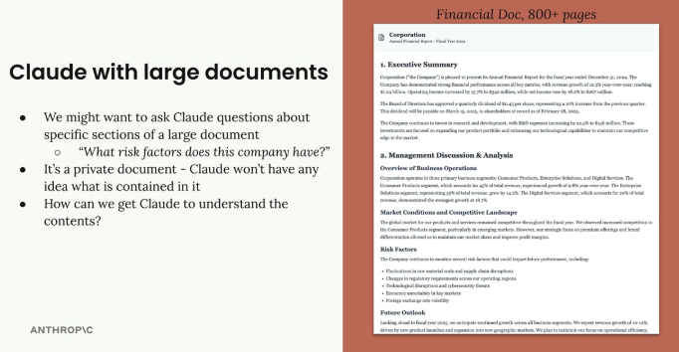
An 800-page financial document: Claude has no built-in knowledge of its private contents.

Option 1: Include Everything in the Prompt
The straightforward approach extracts all text from the document and stuffs it into the prompt alongside the user's question, using tags like <financial_document> and <user_question>. This has serious limitations: there's a hard limit on prompt length, Claude gets less effective with very long prompts, and larger prompts cost more and take longer to process.
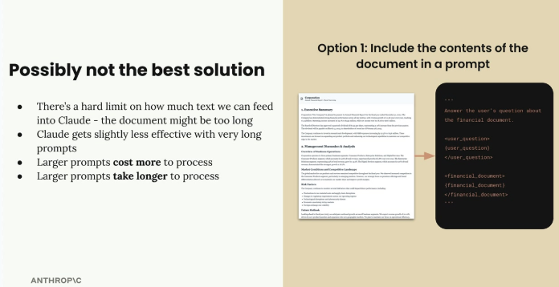
Stuffing the entire document into the prompt runs into hard length limits, reduced effectiveness, higher cost, and slower processing.

Option 2: Break Documents into Chunks
RAG's smarter approach: break the document into smaller chunks during preprocessing, then at query time find the chunks most relevant to the question and include only those in the prompt. Asked "What risks does this company face?", the system would search the chunks, find the "Risk Factors" chunk, and include just that one.
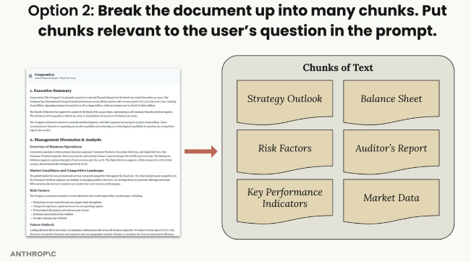
A document broken into topic chunks (Strategy Outlook, Risk Factors, Balance Sheet, Auditor's Report, etc.) during preprocessing.
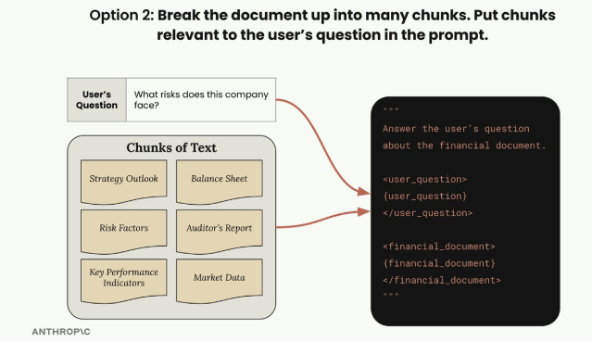
The user's question is matched against the chunks, and only the relevant ones (here, Risk Factors) are inserted into the prompt.

Benefits of RAG
- Focus — Claude works with only the most relevant content.
- Scale — works with very large documents and multiple documents at once.
- Efficiency — smaller prompts cost less and run faster.

Challenges with RAG
- Preprocessing — documents must be chunked ahead of time.
- Search mechanism — you need a way to find which chunks are "relevant".
- Missing context — included chunks might not contain everything Claude needs.
- Chunking strategy — many ways to split text (equal-sized portions vs. structure-based, like headers/sections), each with trade-offs.

When to Use RAG
RAG involves more technical decisions and work than simply stuffing everything into a prompt, so it's worth analyzing whether the benefits outweigh the complexity for a given application. It's especially valuable with very large documents, multiple documents, or when optimizing for cost and performance — trading upfront simplicity for scalability and efficiency.

Practice Questions — Lesson 1
Choose the single best answer for each question (A–E).
1. What problem does RAG primarily solve?
A) Claude forgetting the system prompt
B) Working with documents too large to fit into a single prompt
C) Claude's inability to call external tools
D) Formatting JSON responses
E) Reducing the number of API calls per session
2. Which of the following is NOT listed as a limitation of stuffing the entire document into the prompt?
A) There's a hard limit on prompt length
B) Claude gets less effective with very long prompts
C) Larger prompts cost more to process
D) Larger prompts take longer to process
E) It makes Claude ignore the user's question entirely
3. In the RAG approach, when does document chunking happen?
A) After Claude generates its final answer
B) During a preprocessing step, before any question is asked
C) Only if the user explicitly requests it in the prompt
D) It happens inside Claude's context window automatically
E) During model training
4. Asked "What risks does this company face?", what would a RAG system do?
A) Include the entire 800-page document in the prompt
B) Search the chunks, find the relevant one (e.g. Risk Factors), and include only that
C) Ignore the question and summarize the whole document
D) Ask the user to upload a shorter document
E) Always return the first chunk in the document
5. According to the lesson, what does RAG trade off in exchange for scalability and efficiency?
A) Answer accuracy, always
B) Upfront simplicity — RAG requires more technical decisions and preprocessing work
C) The ability to use JSON schemas
D) Support for multiple documents
E) Claude's context window size

Lesson 2 — Text Chunking Strategies

Core idea
Text chunking is one of the most critical steps in a RAG pipeline — how a document gets broken up directly impacts the quality of the whole system. A poor chunking strategy can insert irrelevant context into prompts, causing completely wrong answers.
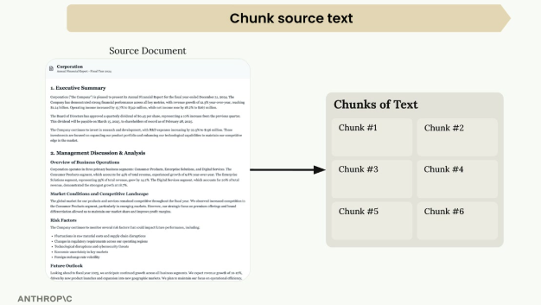
A source document is broken into multiple chunks of text before it can be searched and retrieved.

Why Chunking Quality Matters
Consider a document with sections on medical research and software engineering. With poor chunking, a user asking "How many bugs did engineers fix this year?" might get medical research content instead, simply because the medical section happens to contain the word "bug" in a different context.
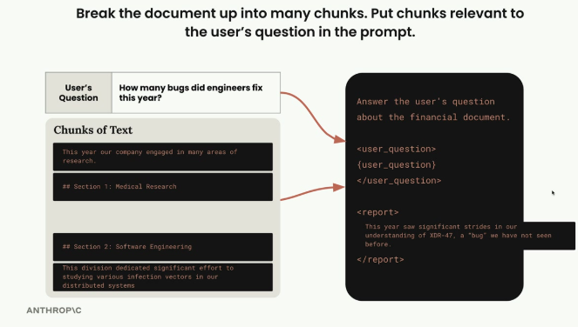
A poorly matched chunk can pull in the wrong section — here, medical research text mentioning "bug" instead of the software engineering section actually about bug fixes.

Three Main Approaches
There are three main chunking strategies, each dividing text differently: size-based (equal-length strings), structure-based (headers, paragraphs, sections), and semantic-based (groups of related sentences).
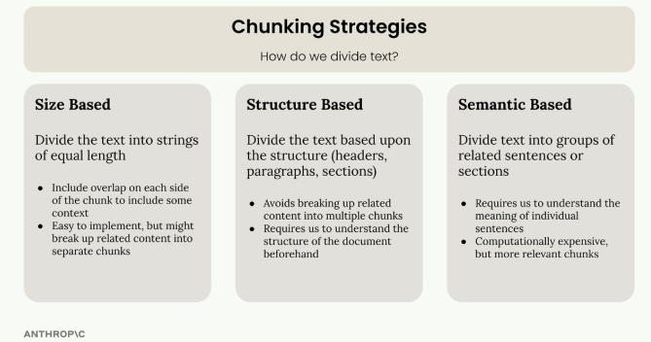
Size Based divides by equal length; Structure Based follows document structure; Semantic Based groups related sentences by meaning.

Size-Based Chunking
The simplest approach: divide text into strings of equal length. A 325-character document might split into three chunks of roughly 108 characters each. It's easy to implement and works with any document type, but words get cut off mid-sentence, chunks lose context from surrounding text, and section headers can be separated from their content.
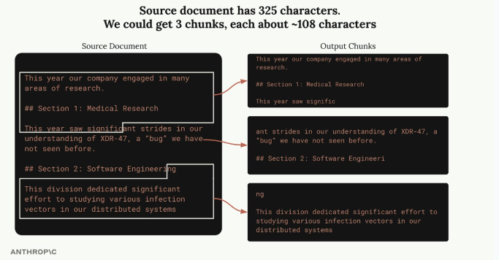
Splitting purely by character count cuts words and section headers mid-way, as seen across these three chunks.
A basic implementation:
def chunk_by_char(text, chunk_size=150, chunk_overlap=20):
chunks = []
start_idx = 0

while start_idx < len(text):
end_idx = min(start_idx + chunk_size, len(text))
chunk_text = text[start_idx:end_idx]
chunks.append(chunk_text)

start_idx = (
end_idx - chunk_overlap if end_idx < len(text) else len(text)
)

return chunks
To reduce cutoff and context-loss problems, chunks can include overlap — each chunk repeats some characters from its neighbors, helping preserve complete words, sentences, and section headers.
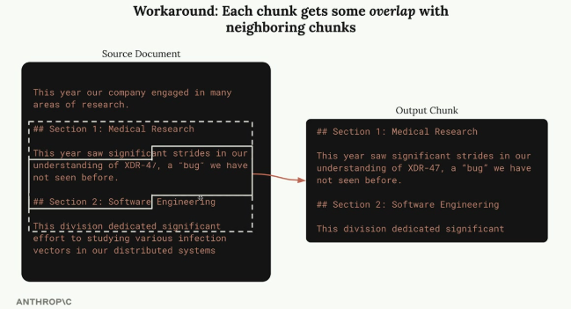
Overlapping the chunk boundaries lets a chunk keep its section header and surrounding context, instead of cutting it off entirely.

Structure-Based Chunking
This approach divides text based on the document's natural structure — headers, paragraphs, sections. It works great for well-formatted documents like Markdown, e.g. splitting on header markers:
def chunk_by_section(document_text):
pattern = r"\n## "
return re.split(pattern, document_text)
This gives the cleanest, most meaningful chunks since each represents a complete section — but it only works when the document structure is guaranteed. Many real-world documents (plain text, PDFs) lack clear structural markers.

Semantic-Based Chunking
The most sophisticated approach: split text into sentences, then use NLP to determine how related consecutive sentences are, building chunks from groups of related sentences. It's computationally expensive and requires understanding sentence meaning, but produces the most relevant chunks.

Sentence-Based Chunking
A practical middle ground: split text into individual sentences with a regular expression, then group them into chunks with optional overlap between groups:
def chunk_by_sentence(text, max_sentences_per_chunk=5, overlap_sentences=1):
sentences = re.split(r"(?<=[.!?])\s+", text)

chunks = []
start_idx = 0

while start_idx < len(sentences):
end_idx = min(start_idx + max_sentences_per_chunk, len(sentences))
current_chunk = sentences[start_idx:end_idx]
chunks.append(" ".join(current_chunk))

start_idx += max_sentences_per_chunk - overlap_sentences

if start_idx < 0:
start_idx = 0

return chunks

Choosing Your Strategy
- Structure-based — best results when you control document formatting, like internal company reports.
- Sentence-based — a good middle ground for most text documents.
- Size-based — the most reliable fallback, works with any content type including code; often the go-to choice in production when combined with overlap.
There's no single "best" chunking strategy — the right approach depends on the specific documents, use case, and the trade-off between implementation complexity and chunk quality.

Practice Questions — Lesson 2
Choose the single best answer for each question (A–E).
1. Why can poor chunking cause a RAG system to give wrong answers?
A) It makes the API calls too slow
B) It can insert irrelevant context into the prompt, like an unrelated section that happens to share a keyword
C) It always exceeds the token limit
D) It disables the tools parameter
E) It prevents Claude from receiving any chunk at all
2. What is the simplest chunking strategy?
A) Semantic-based chunking
B) Structure-based chunking
C) Size-based chunking
D) Sentence-based chunking
E) Random chunking
3. What problem does adding overlap between chunks help solve?
A) It removes the need for a search mechanism
B) It prevents words, sentences, and headers from being cut off between chunks
C) It makes chunking computationally cheaper
D) It guarantees semantic relevance
E) It eliminates the need for preprocessing
4. When does structure-based chunking work best?
A) On any plain text with no formatting
B) Only on scanned PDF images
C) When there are guarantees about the document's structure, like Markdown headers
D) Only when overlap is disabled
E) Only for code files
5. Which chunking strategy is described as computationally expensive but producing the most relevant chunks?
A) Size-based chunking
B) Structure-based chunking
C) Semantic-based chunking
D) Sentence-based chunking
E) Fixed-token chunking

Lesson 3 — Text Embeddings

Core idea
After chunking a document, the next step in a RAG pipeline is finding which chunks are most relevant to a user's question — a search problem. Semantic search, the most common approach, uses text embeddings to understand the meaning and context of both the question and each chunk, rather than matching exact keywords.

Semantic Search
Unlike keyword-based search that looks for exact word matches, semantic search utilizes text embeddings to better understand the user's question and what each chunk of text is really talking about.
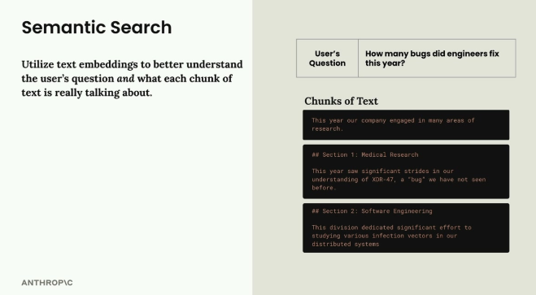
Semantic search relies on embeddings to capture meaning, not just literal keyword overlap.

Text Embeddings
A text embedding is a numerical representation of the meaning contained in some text — converting words and sentences into a format computers can work with mathematically. Text is fed into an embedding model, which outputs a long list of numbers (the embedding), each ranging from -1 to +1 and representing different qualities or features of the input text.
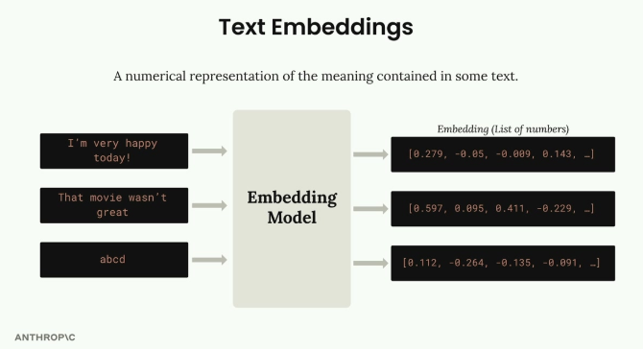
An embedding model turns each piece of text into a list of numbers — its embedding.

Understanding the Numbers
Each number in an embedding is essentially a "score" for some quality of the text, but we don't know precisely what each number represents. It's helpful to imagine one number as "how happy the text is" or "how much it talks about oceans", but these are just conceptual examples — the actual meaning of each dimension is learned by the model during training and isn't directly interpretable by humans.
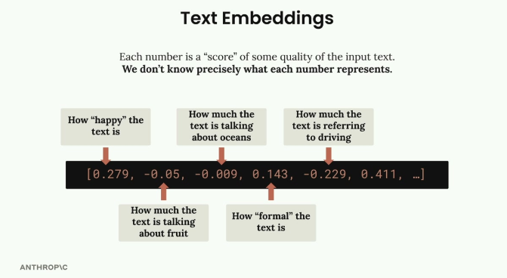
Illustrative, not literal: each number in the embedding vector conceptually maps to some quality of the text, but the real mapping isn't human-interpretable.

VoyageAI for Embeddings
Anthropic doesn't currently provide embedding generation, so the recommended provider is VoyageAI. This requires signing up for a separate VoyageAI account, getting an API key (free to get started), and adding the key to the environment variables.

Implementation
Install the VoyageAI library:
%pip install voyageai
Then set up the client and create a function to generate embeddings:
from dotenv import load_dotenv
import voyageai

load_dotenv()
client = voyageai.Client()

def generate_embedding(text, model="voyage-3-large", input_type="query"):
result = client.embed([text], model=model, input_type=input_type)
return result.embeddings[0]
Running this on a text chunk returns a list of floating-point numbers — the embedding. Generating it is quick and straightforward; the real challenge is comparing embeddings to determine which chunks are most similar to a user's question, which is the core of semantic search.

Practice Questions — Lesson 3
Choose the single best answer for each question (A–E).
1. What kind of problem is finding the most relevant chunks for a user's question?
A) A formatting problem
B) A search problem
C) A billing problem
D) A tokenization problem
E) A translation problem
2. How does semantic search differ from keyword-based search?
A) It only works with numeric data
B) It uses text embeddings to understand meaning, instead of matching exact words
C) It requires no preprocessing at all
D) It replaces the need for chunking
E) It only works with structure-based chunks
3. What is a text embedding?
A) A summary of the text written by Claude
B) A numerical representation of the meaning contained in some text
C) A compressed version of the original text file
D) A list of keywords extracted from the text
E) The chunk's character count
4. According to the lesson, do we know precisely what each number in an embedding represents?
A) Yes, each number always represents a fixed, documented quality
B) No — we don't know precisely; conceptual examples like "how happy the text is" are illustrative, not literal
C) Yes, but only for VoyageAI's embedding models
D) No, embeddings don't contain numbers at all
E) Yes, the number of dimensions tells us exactly what each one means
5. Which provider does the lesson recommend for generating embeddings, since Anthropic doesn't offer this directly?
A) OpenAI
B) Google
C) VoyageAI
D) Hugging Face
E) Cohere

Lesson 4 — The Full RAG Flow

Core idea
This lesson walks through the complete RAG pipeline end to end with a worked numeric example, showing exactly how chunking, embeddings, a vector database, and cosine similarity work together to retrieve relevant information and generate a response.

Step 1: Chunk Your Source Text
The source document is split into chunks — here, two simple sections: Section 1 (Medical Research), about "significant strides in our understanding of XDR-47, a 'bug' we have not seen before", and Section 2 (Software Engineering), about "studying various infection vectors in our distributed systems".

Step 2: Generate Embeddings
Each chunk is converted into a numerical embedding. To make the math easy to follow, imagine a simplified embedding model that always returns exactly two numbers: the first for how much the text talks about the medical field, the second for how much it talks about software engineering. The medical section gets roughly [0.97, 0.34] — mostly medical, with a little software due to the word "bug". The software section gets roughly [0.30, 0.97] — mostly software, with some medical undertones from "infection vectors".
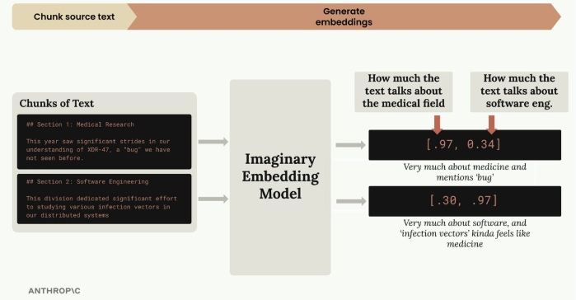
A simplified two-number embedding model scores each chunk on "medical" vs. "software engineering", showing why shared words like "bug" create some cross-topic signal.
The embedding API typically normalizes each vector to a magnitude of 1.0 (handled automatically) — giving normalized vectors like [0.944, 0.331] and [0.295, 0.955], which can be visualized as points on a unit circle.
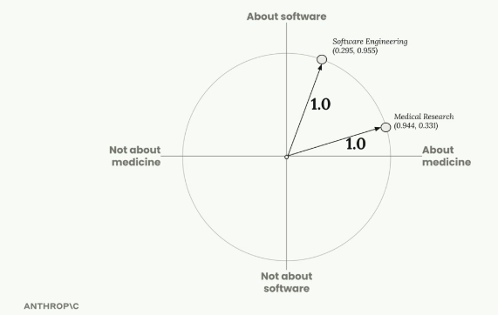
Normalized embeddings for the two chunks plotted on a unit circle, one axis for "about medicine" and one for "about software".

Step 3: Store in Vector Database
The embeddings are stored in a vector database — a specialized database optimized for storing, comparing, and searching long lists of numbers like embeddings. Everything up to this point is preprocessing done ahead of time; the pipeline now waits for a user query.
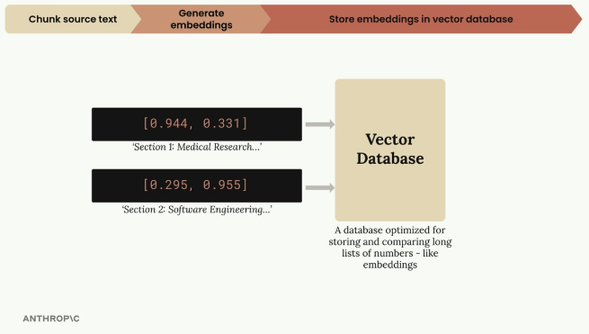
Chunk embeddings are stored in a vector database, completing the preprocessing stage of the pipeline.

Step 4: Process User Query
When a user asks something like "I'm curious about the company. In particular, what did the software engineering dept do this year?", the query is run through the same embedding model — here landing around [0.1, 0.89]: low medical score, high software score.
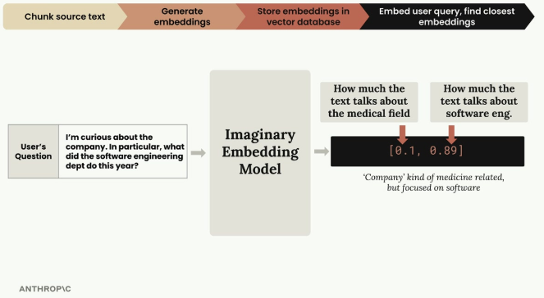
The user's question is embedded with the same model used for the chunks, so it can be compared directly.
After normalization, the query embedding becomes [0.112, 0.993].
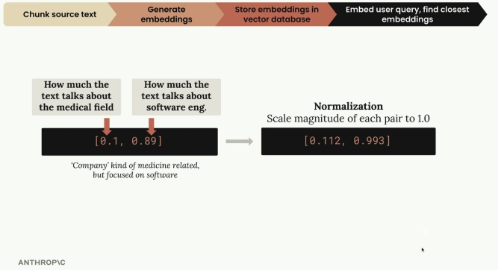
The raw query embedding is scaled to a magnitude of 1.0, matching the normalization already applied to the stored chunk embeddings.

Step 5: Find Similar Embeddings
The query embedding is sent to the vector database, which returns the most similar stored embeddings — in this case, the software engineering section, since it's the closest match to the question.
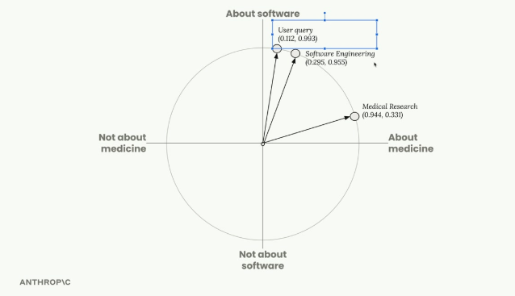
The normalized user query sits much closer, angularly, to the Software Engineering chunk than to Medical Research.

How Similarity Works: Cosine Similarity
The vector database uses cosine similarity — the cosine of the angle between two vectors — to rank matches. Results range from -1 to 1: close to 1 means high similarity, close to -1 means very different, and 0 means perpendicular (no relationship). Here, the similarity between the query and the software engineering chunk is 0.983 (very high), versus only 0.398 for the medical research chunk.
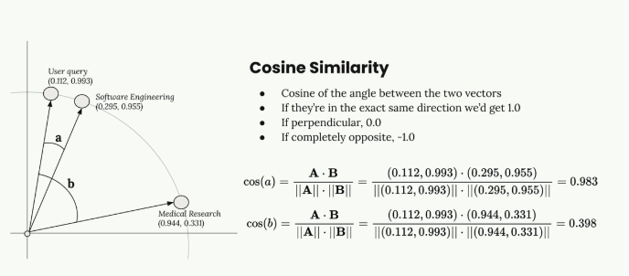
cos(a) = 0.983 between the query and the Software Engineering chunk; cos(b) = 0.398 between the query and the Medical Research chunk — the higher value wins.
Vector database documentation often reports "cosine distance" instead, calculated as (1 − cosine similarity). With cosine distance, values close to 0 mean high similarity and larger values mean less similarity — often easier to interpret.

Step 6: Create the Final Prompt
Finally, the user's question and the most relevant chunk found are combined into a prompt and sent to Claude for a response.
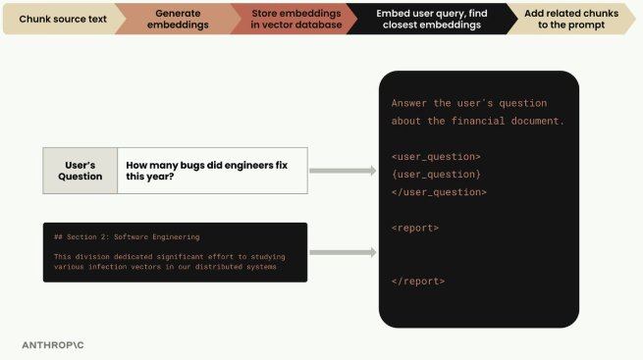
The winning chunk (Section 2: Software Engineering) is inserted into the prompt alongside the user's original question.
Answer the user's question about the financial document.

<user_question>
How many bugs did engineers fix this year?
</user_question>

<report>
## Section 2: Software Engineering
This division dedicated significant effort to studying various infection vectors in our distributed systems
</report>
That's the complete RAG pipeline: chunk, embed, store, embed the query, retrieve by similarity, and prompt Claude with only the relevant context — successfully retrieving the right information based on semantic similarity rather than exact keyword overlap.

Practice Questions — Lesson 4
Choose the single best answer for each question (A–E).
1. What is the correct order of the full RAG pipeline described in this lesson?
A) Embed query → chunk text → store in vector database → generate embeddings
B) Chunk text → generate embeddings → store in vector database → embed user query → find similar embeddings → build final prompt
C) Build final prompt → chunk text → generate embeddings → store in vector database
D) Store in vector database → chunk text → embed user query → generate embeddings
E) Generate embeddings → build final prompt → chunk text → store in vector database
2. What is normalization doing to an embedding vector?
A) Removing all negative numbers
B) Scaling the vector so its magnitude equals 1.0
C) Converting the vector into text again
D) Reducing the vector to a single number
E) Sorting the vector's values from smallest to largest
3. In the worked example, why does the software engineering chunk end up as the best match for the user's query?
A) It was stored first in the vector database
B) It has the highest cosine similarity to the query embedding
C) It is alphabetically first
D) The medical research chunk was deleted
E) It's the shortest chunk
4. What does a cosine similarity close to 0 indicate between two embeddings?
A) They are nearly identical in meaning
B) They are perpendicular — essentially no relationship
C) They are completely opposite in meaning
D) One of the embeddings is invalid
E) The vectors weren't normalized correctly
5. How is cosine distance calculated from cosine similarity?
A) cosine similarity squared
B) 1 − cosine similarity
C) cosine similarity × 2
D) The absolute value of cosine similarity
E) 1 / cosine similarity

Lesson 5 — Implementing the RAG Flow

Core idea
This lesson turns the conceptual RAG flow into real code: chunk the text, generate embeddings, store them in a vector database, embed the user's question, and search for the most relevant chunks.

The Five-Step RAG Implementation
- Chunk the text by section.
- Generate embeddings for each chunk.
- Create a vector store and add each embedding to it.
- Generate an embedding for the user's question.
- Search the store to find the most relevant chunks.
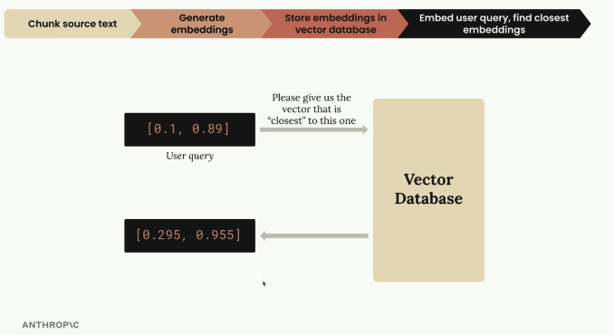
The user query embedding is sent to the vector database, which returns the closest stored embedding.

Step 1: Chunking the Text
Load the document and split it into sections using the same chunk_by_section function from earlier:
with open("./report.md", "r") as f:
text = f.read()

chunks = chunk_by_section(text)
chunks[2] # Test to see the table of contents

Step 2: Generate Embeddings
Create embeddings for all chunks at once. The embedding function has been updated to handle both single strings and lists of strings, making it more efficient for batch processing:
embeddings = generate_embedding(chunks)

Step 3: Store in Vector Database
Create the vector store and populate it with embeddings and their associated text:
store = VectorIndex()

for embedding, chunk in zip(embeddings, chunks):
store.add_vector(embedding, {"content": chunk})
Both the embedding and the original text content are stored — this matters because a search later needs to return the actual text, not just the numerical embedding values.

Why Store the Original Text?
Getting back just the embedding numbers from a query isn't useful — the actual text used to generate those embeddings is what's needed. That's why the original chunk text (or a reference to it) is stored alongside each embedding.

Step 4: Process User Queries
Generate an embedding for the user's question:
user_embedding = generate_embedding("What did the software engineering dept do last year?")

Step 5: Find Relevant Content
Search the vector store for the most similar chunks:
results = store.search(user_embedding, 2)

for doc, distance in results:
print(distance, "\n", doc["content"][0:200], "\n")
This returns the two most relevant chunks along with their similarity scores (cosine distances).

Understanding the Results
Running the example query about the software engineering department returns Section 2: Software Engineering at a distance of 0.71 (closest match) and the Methodology section at 0.72 (second closest). Lower distance values mean higher similarity, so Section 2 is the most relevant to the query.

What's Next?
This implementation works for basic cases, but there are scenarios where it falls short. The key takeaway: RAG is fundamentally about converting text to numbers (embeddings), storing those numbers efficiently, and using mathematical similarity to find relevant content when users ask questions.

Practice Questions — Lesson 5
Choose the single best answer for each question (A–E).
1. What is the correct order of the five-step RAG implementation in this lesson?
A) Search store → chunk text → generate embeddings → embed query → create vector store
B) Chunk text → generate embeddings → create vector store → embed user query → search store
C) Create vector store → embed user query → chunk text → generate embeddings → search store
D) Generate embeddings → search store → chunk text → create vector store → embed user query
E) Embed user query → search store → chunk text → generate embeddings → create vector store
2. What does store.add_vector(embedding, {"content": chunk}) store alongside the embedding?
A) Nothing else — only the embedding is stored
B) The original chunk text, so it can be returned later
C) The user's question
D) The API key used to generate the embedding
E) A cosine similarity score
3. Why is it important to store the original chunk text alongside its embedding?
A) It speeds up the embedding model
B) Because querying the vector store alone only returns numbers, not usable text
C) It's required by the embedding API
D) It reduces the size of the vector database
E) It removes the need for normalization
4. In the example query results, what does a lower distance value mean?
A) Lower relevance to the query
B) Higher similarity to the query
C) The chunk is shorter
D) The chunk was stored earlier
E) The embedding failed to normalize
5. What does store.search(user_embedding, 2) return?
A) The 2 chunks stored first in the database
B) The 2 most similar chunks to the query, with their distances
C) A single merged chunk of exactly 2 sentences
D) The 2 chunks with the lowest word count
E) 2 randomly selected chunks

Lesson 6 — BM25 Lexical Search

Core idea
Semantic search alone doesn't always return the best results — it can miss exact term matches, like a specific incident ID. The solution is to combine semantic search with lexical search (exact term matching) using BM25, a hybrid approach that catches both conceptual and literal matches.

The Problem with Semantic Search Alone
Searching for a specific ID like "INC-2023-Q4-011", semantic search may return sections that are conceptually related but don't actually contain the exact term — for example, a financial analysis section with no mention of the incident at all — because it optimizes for conceptual similarity rather than exact term matching.

Hybrid Search Strategy
Run semantic and lexical search in parallel, then merge the results. Semantic search finds conceptually related content using embeddings; lexical search finds exact term matches using classic text search; merging both gives better accuracy than either alone.
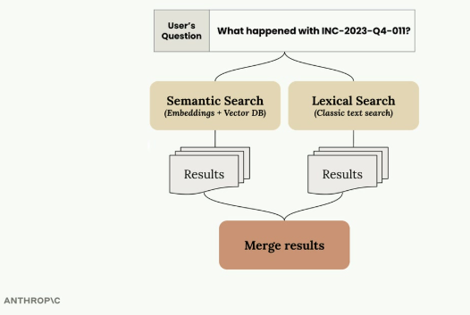
A user's question is run through both semantic search (embeddings + vector DB) and lexical search (classic text search) in parallel, then the results are merged.

How BM25 Works
BM25 (Best Match 25) is a popular lexical search algorithm. It tokenizes the query into individual terms (e.g. "a INC-2023-Q4-011" becomes ["a", "INC-2023-Q4-011"]), counts how often each term appears across all documents, gives higher importance to terms that appear less frequently (rare terms like an incident ID score higher than common words like "a"), and returns the chunks containing more instances of the higher-weighted terms.
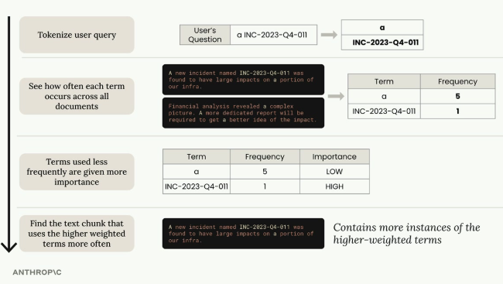
Tokenize the query, count term frequency across documents, weight rare terms higher, then find the chunk with the most instances of the higher-weighted terms.

Implementing BM25 Search
A basic BM25 search setup:
# 1. Chunk your text by sections
chunks = chunk_by_section(text)

# 2. Create a BM25 store and add documents
store = BM25Index()
for chunk in chunks:
store.add_document({"content": chunk})

# 3. Search the store
results = store.search("What happened with INC-2023-Q4-011?", 3)

# Print results
for doc, distance in results:
print(distance, "\n", doc["content"][:200], "\n----\n")
This prioritizes sections that actually contain the specific search terms, especially rare ones like incident IDs — properly surfacing the Software Engineering and Cybersecurity sections, both of which actually contain the incident ID.

Why This Works Better
- Higher weight for rare, specific terms.
- Ignores common words that don't add search value.
- Term frequency, not meaning — focuses on occurrence rather than semantic similarity.
- Especially strong for technical terms, IDs, and specific phrases.
Semantic and lexical search have complementary strengths: semantic search understands context and meaning, lexical search ensures exact terms aren't missed. Combining them creates a more robust system for both conceptual queries and specific lookups. The next step is learning how to merge results from both systems into a unified hybrid search.

Practice Questions — Lesson 6
Choose the single best answer for each question (A–E).
1. Why might semantic search alone fail to find a specific incident ID?
A) Semantic search can't process numbers
B) It optimizes for conceptual similarity, so it can miss or over-include content based on meaning rather than exact terms
C) Semantic search always returns zero results for IDs
D) Semantic search requires a BM25 index first
E) The vector database doesn't support text at all
2. What does BM25 stand for/represent in this lesson?
A) A type of embedding model
B) A popular algorithm for lexical search in RAG systems
C) A vector database provider
D) A chunking strategy
E) A cosine similarity threshold
3. In BM25, how are terms weighted?
A) All terms get equal weight
B) Terms that appear less frequently across documents get higher importance
C) Longer terms always get higher importance
D) Only terms in the title get weighted
E) Terms are weighted alphabetically
4. What is the first step BM25 performs on a search query?
A) Generating an embedding
B) Tokenizing the query into individual terms
C) Normalizing the vector
D) Calling the vector database
E) Ranking documents by length
5. What is the benefit of a hybrid search strategy over semantic search alone?
A) It removes the need for chunking
B) It combines conceptual matching with exact term matching for better overall accuracy
C) It eliminates the need for a vector database
D) It always returns fewer results
E) It replaces cosine similarity with word count entirely

Lesson 7 — A Multi-Index RAG Pipeline

Core idea
With separate semantic (VectorIndex) and lexical (BM25Index) implementations built, the next step is combining them into a unified pipeline that leverages both, using a technique called reciprocal rank fusion to merge their rankings fairly.

The Multi-Index Architecture
VectorIndex and BM25Index share nearly identical APIs — both have add_document() and search() methods. This consistency makes it straightforward to wrap them together in a new class called Retriever, which forwards user queries to both indexes, collects their results, and merges them via reciprocal rank fusion.

Understanding Reciprocal Rank Fusion
Merging results from different search methods isn't as simple as concatenating lists — each method uses a different scoring system, so the rankings need to be normalized and combined fairly. Searching for "INC-2023-Q4-011", VectorIndex might rank Section 2, then Section 7, then Section 6; BM25Index might rank Section 6, then Section 2, then Section 7.
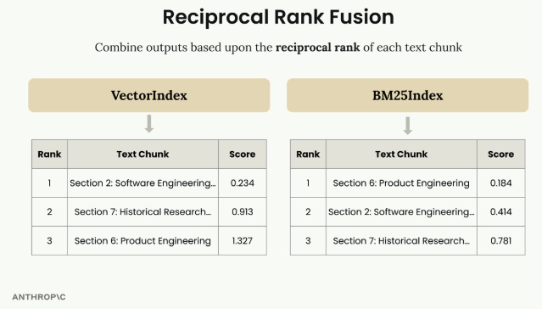
VectorIndex and BM25Index each produce their own ranked list and score for the same set of chunks.
The two rankings are combined into a single table showing each chunk's rank from both indexes.
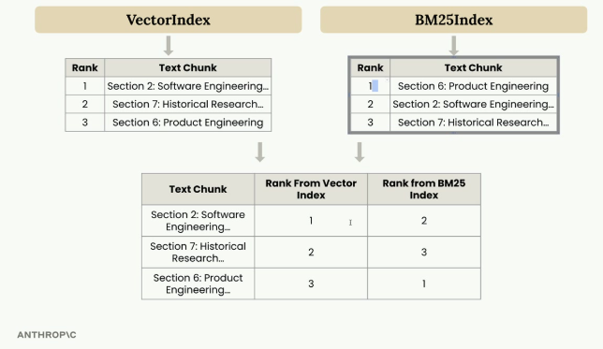
Each text chunk's rank from VectorIndex and from BM25Index side by side, ready for fusion.

The RRF Formula
The RRF formula sums 1/(k + rank) across all rankings for each document, where k is a constant (often 60, but 1 is used here for clearer results) and rank is the document's position in each ranking:
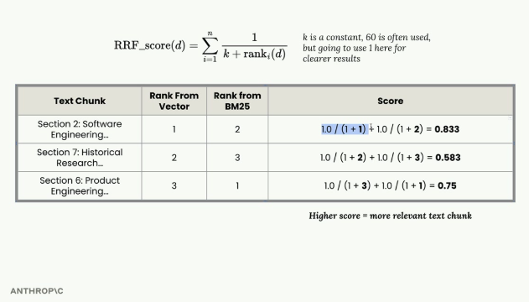
Section 2 scores 0.833, Section 7 scores 0.583, and Section 6 scores 0.75 by summing 1/(1+rank) across both indexes.
Sorting by score gives the final ranking: Section 2 (0.833), Section 6 (0.75), Section 7 (0.583) — Section 2 rises to the top because it performed well in both indexes.
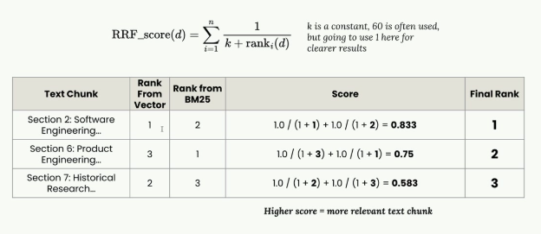
The same scores sorted into a Final Rank column: Section 2 first, Section 6 second, Section 7 third.

Implementation Details
The Retriever class wraps multiple search indexes behind a unified interface:
class Retriever:
def __init__(self, *indexes: SearchIndex):
if len(indexes) == 0:
raise ValueError("At least one index must be provided")
self._indexes = list(indexes)

def add_document(self, document: Dict[str, Any]):
for index in self._indexes:
index.add_document(document)

def search(self, query_text: str, k: int = 1, k_rrf: int = 60):
# Get results from all indexes
all_results = []
for idx, results in enumerate(all_results):
for rank, (doc, _) in enumerate(results):
# Track document ranks across indexes
# Apply RRF scoring formula
# Return merged and sorted results
The key insight: maintaining consistent APIs across different search implementations lets them be combined easily, without tight coupling.

Testing the Hybrid Approach
The earlier vector-only search for "what happened with INC-2023-Q4-011?" put Section 10 (Cybersecurity) first but Section 3 (financial analysis) second, ahead of the more relevant software engineering section. With the hybrid retriever, results improve: Section 10 (Cybersecurity Analysis) most relevant, Section 2 (Software Engineering) second, Section 5 (Legal Developments) third — demonstrating how combining semantic and lexical search overcomes the limitations of either alone.

Extensibility
Since every index implements the same SearchIndex protocol (add_document() and search()), new search methodologies — a keyword-based index, a graph-based search, a specialized domain index — can be added just by implementing the same interface; the Retriever automatically incorporates it into the fusion process.
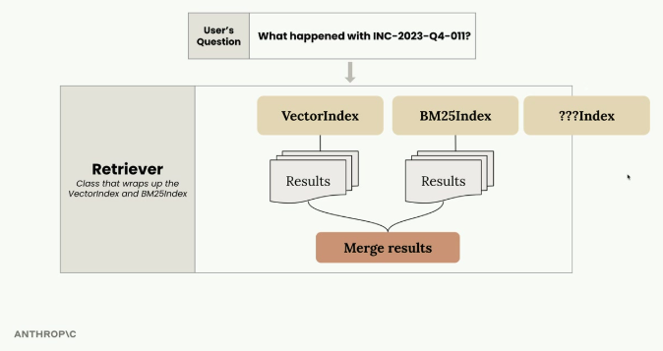
The Retriever wraps VectorIndex and BM25Index today, but any additional ???Index implementing the same interface slots in the same way.
This modular approach keeps each search implementation focused and testable while providing a clean way to combine their strengths in the final system.
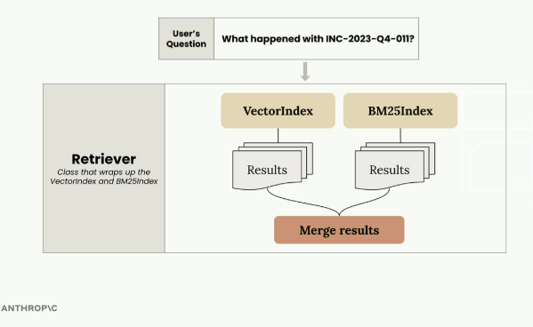
The Retriever as implemented in this lesson: VectorIndex and BM25Index results merged into one ranked list.

Practice Questions — Lesson 7
Choose the single best answer for each question (A–E).
1. What makes it easy to combine VectorIndex and BM25Index into a single Retriever?
A) They both run on the same server
B) They share nearly identical APIs (add_document() and search())
C) BM25Index is a subclass of VectorIndex
D) They both use cosine similarity internally
E) They were trained on the same embedding model
2. Why can't you just concatenate the result lists from VectorIndex and BM25Index?
A) The lists are always the same length
B) Each method uses a different scoring system, so scores aren't directly comparable
C) Concatenating lists is not supported in Python
D) BM25Index never returns more than one result
E) VectorIndex results are always better and should be used alone
3. In the RRF formula 1/(k + rank), what happens to a document's score contribution as its rank number gets higher (worse)?
A) The score contribution increases
B) The score contribution decreases
C) The score becomes negative
D) The rank is ignored entirely
E) The formula becomes undefined
4. In the worked example, why does Section 2 end up with the highest final RRF score?
A) It was the only chunk returned by both indexes
B) It ranked well (had good rank positions) in both VectorIndex and BM25Index
C) It has the most characters
D) It was manually pinned to first place
E) BM25Index ignored it entirely
5. According to the lesson, how could a new search method (e.g. graph-based search) be added to the Retriever?
A) It's not possible without rewriting the Retriever class
B) By implementing the same SearchIndex interface (add_document() and search())
C) By replacing BM25Index entirely
D) Only Anthropic can add new index types
E) By changing the RRF formula's constant k to a negative number

